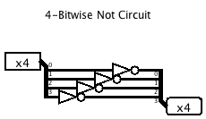

In this 4-Bitwise Not Circuit I made, the process that is happening is as follows;

There is a 4-Bit pin at the left side which inputs data as 1s and 0s. The input is then split into 4 unique wires which are then fed into Not gates (aka inverters) that negate the value they came in as. The New numbers are then carried on their individual wires into another splitter that puts them back together and to the pin as output.

EX| If the inputs were “1111” the output I would get from my circuit would be “0000”